AWS Solutions Architect

Section 4: High Availability and Scalability – ELB & ASG

# 43. Elastic Load Balancer - Overview

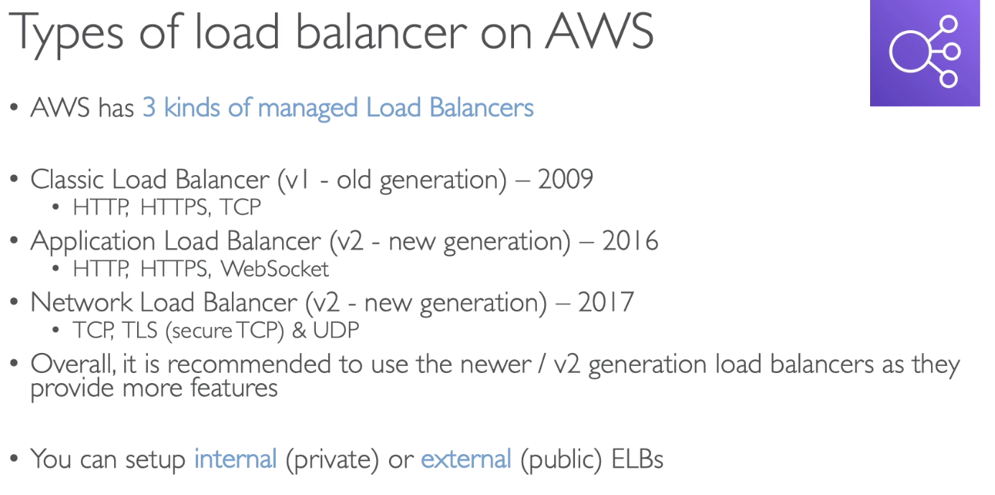

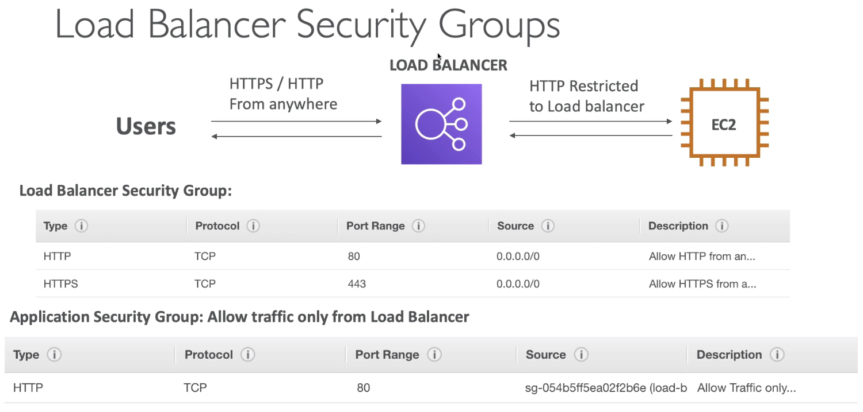

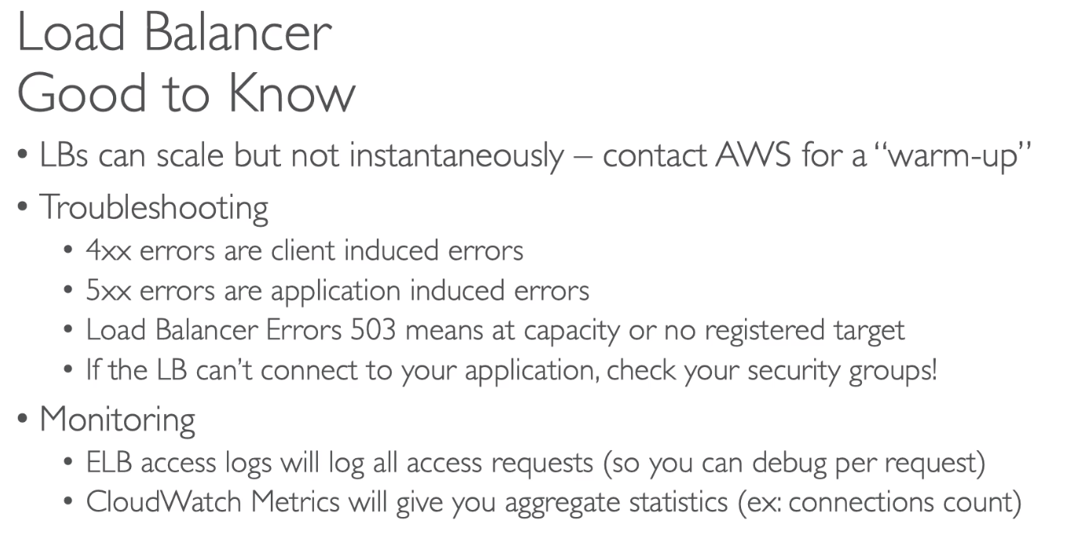

# 44. Gateway Load Balancer

<https://aws.amazon.com/blogs/aws/introducing-aws-gateway-load-ntbalancer-easy-deployment-scalability-and-high-availability-for-partner-appliances/>

On Nov 10th 2020, AWS released a Gateway Load Balancer.

Not an important topic right now.

# 45. Classis Load Balancer

*May not be very prominent in the exam

# 46. Application Load Balancer (ALB) with Hands on

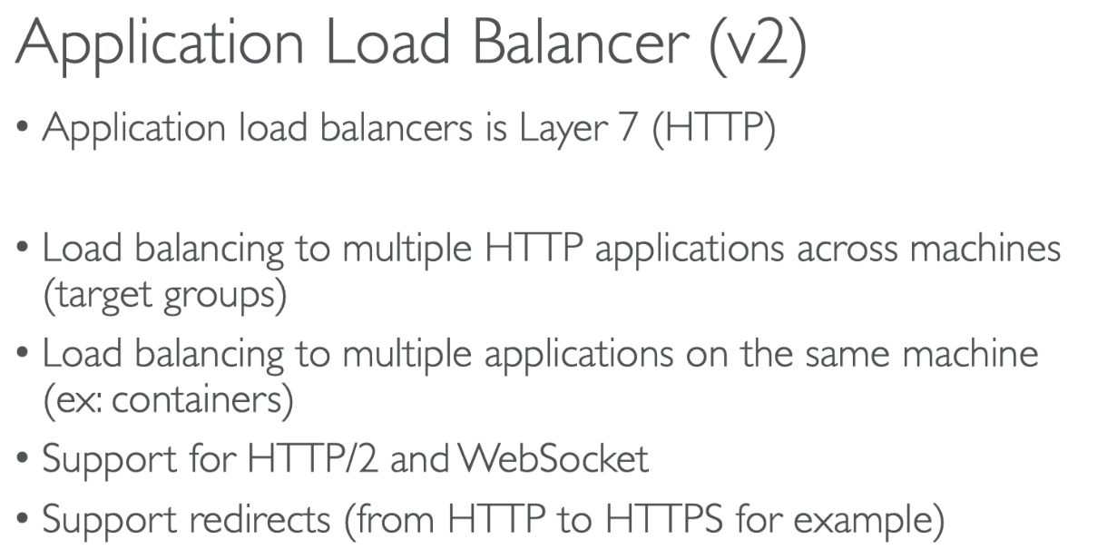

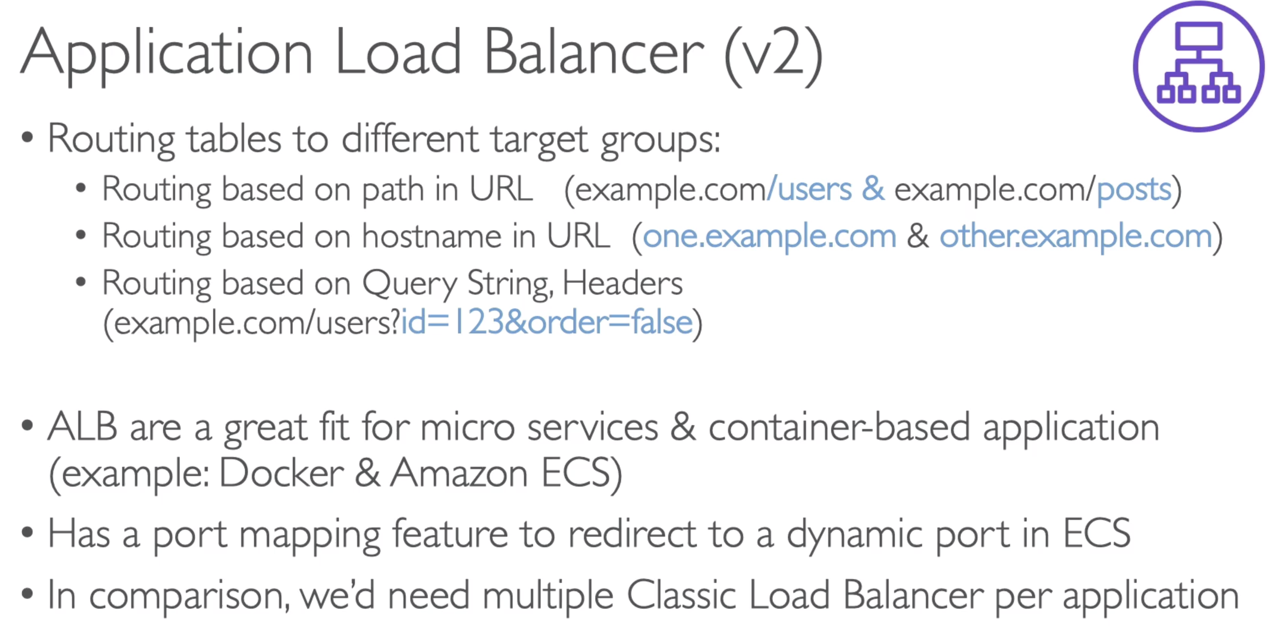

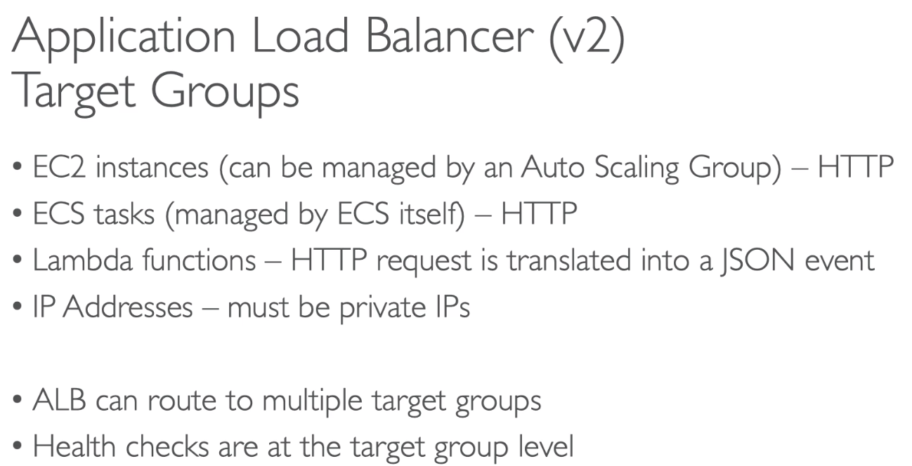

# 47. Network Load Balancer (NLB) with Hands on

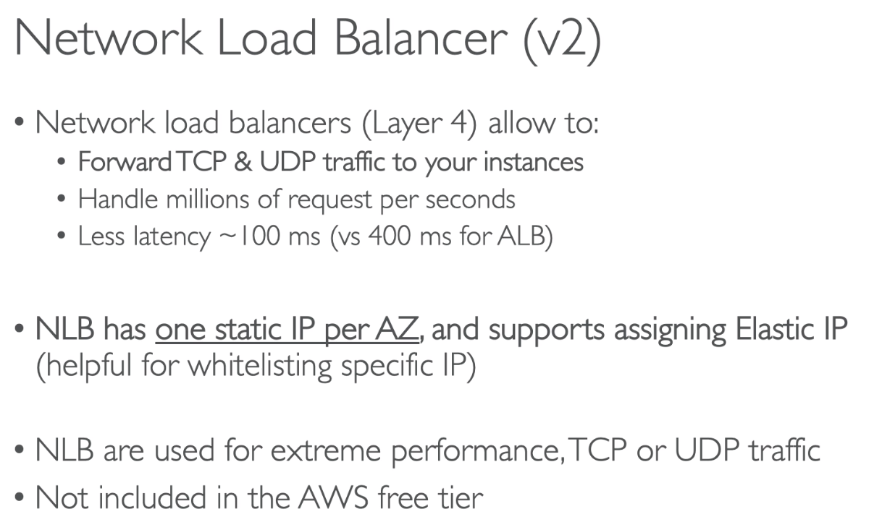

How to enable Stickiness:

* Go to ALB 🡪 Target group…
* Edit Attributes
* Click check box to enable stickiness

# 49. ELB - Cross Zone Load Balancing

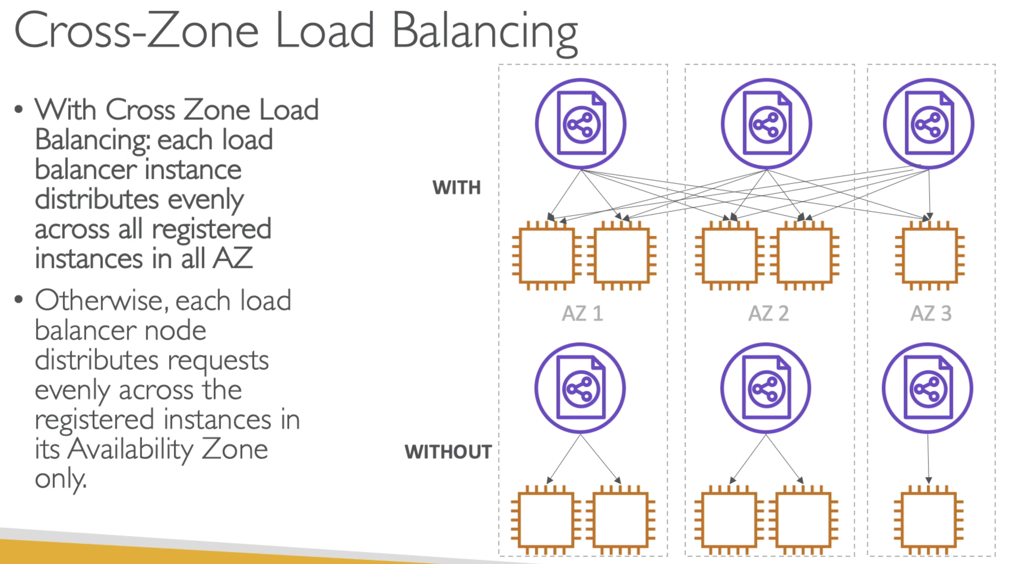

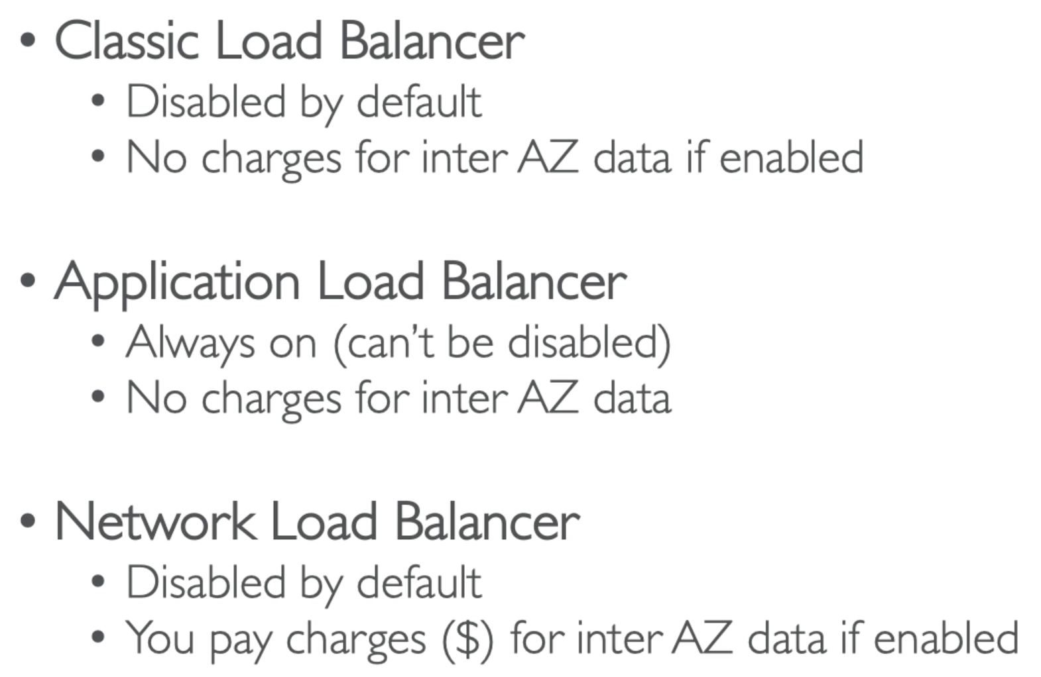

How to Enable Cross Zone in CLB

* Open CLB
* Description tab 🡪 go at the bottom of the page
* Click button to “Change Cross-zone load balancing setting”
* Click “Enable” and save it

# 50. *ELB – SSL Certificate

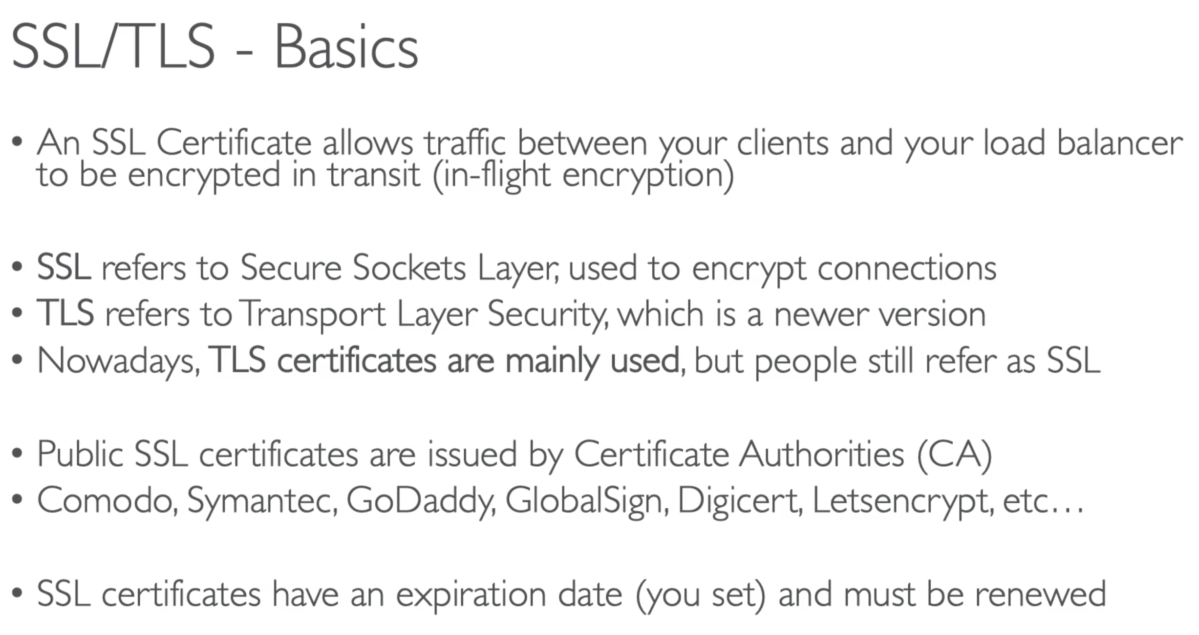

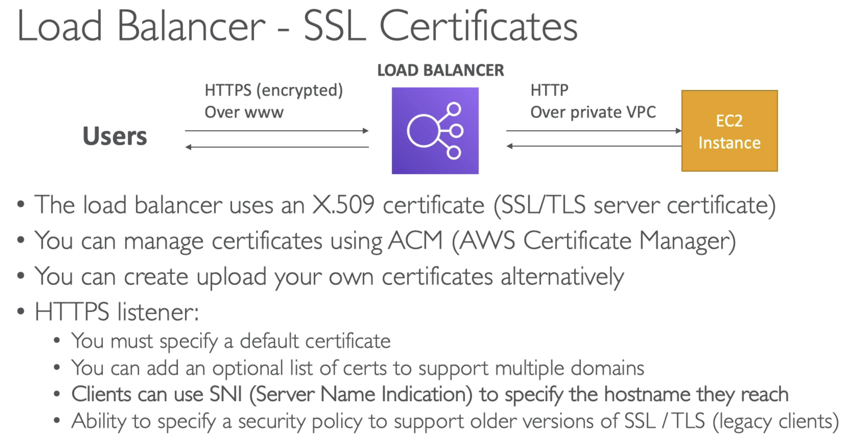

Using SNI, you are able to have multiple target groups for different websites to use different SSL certificates.

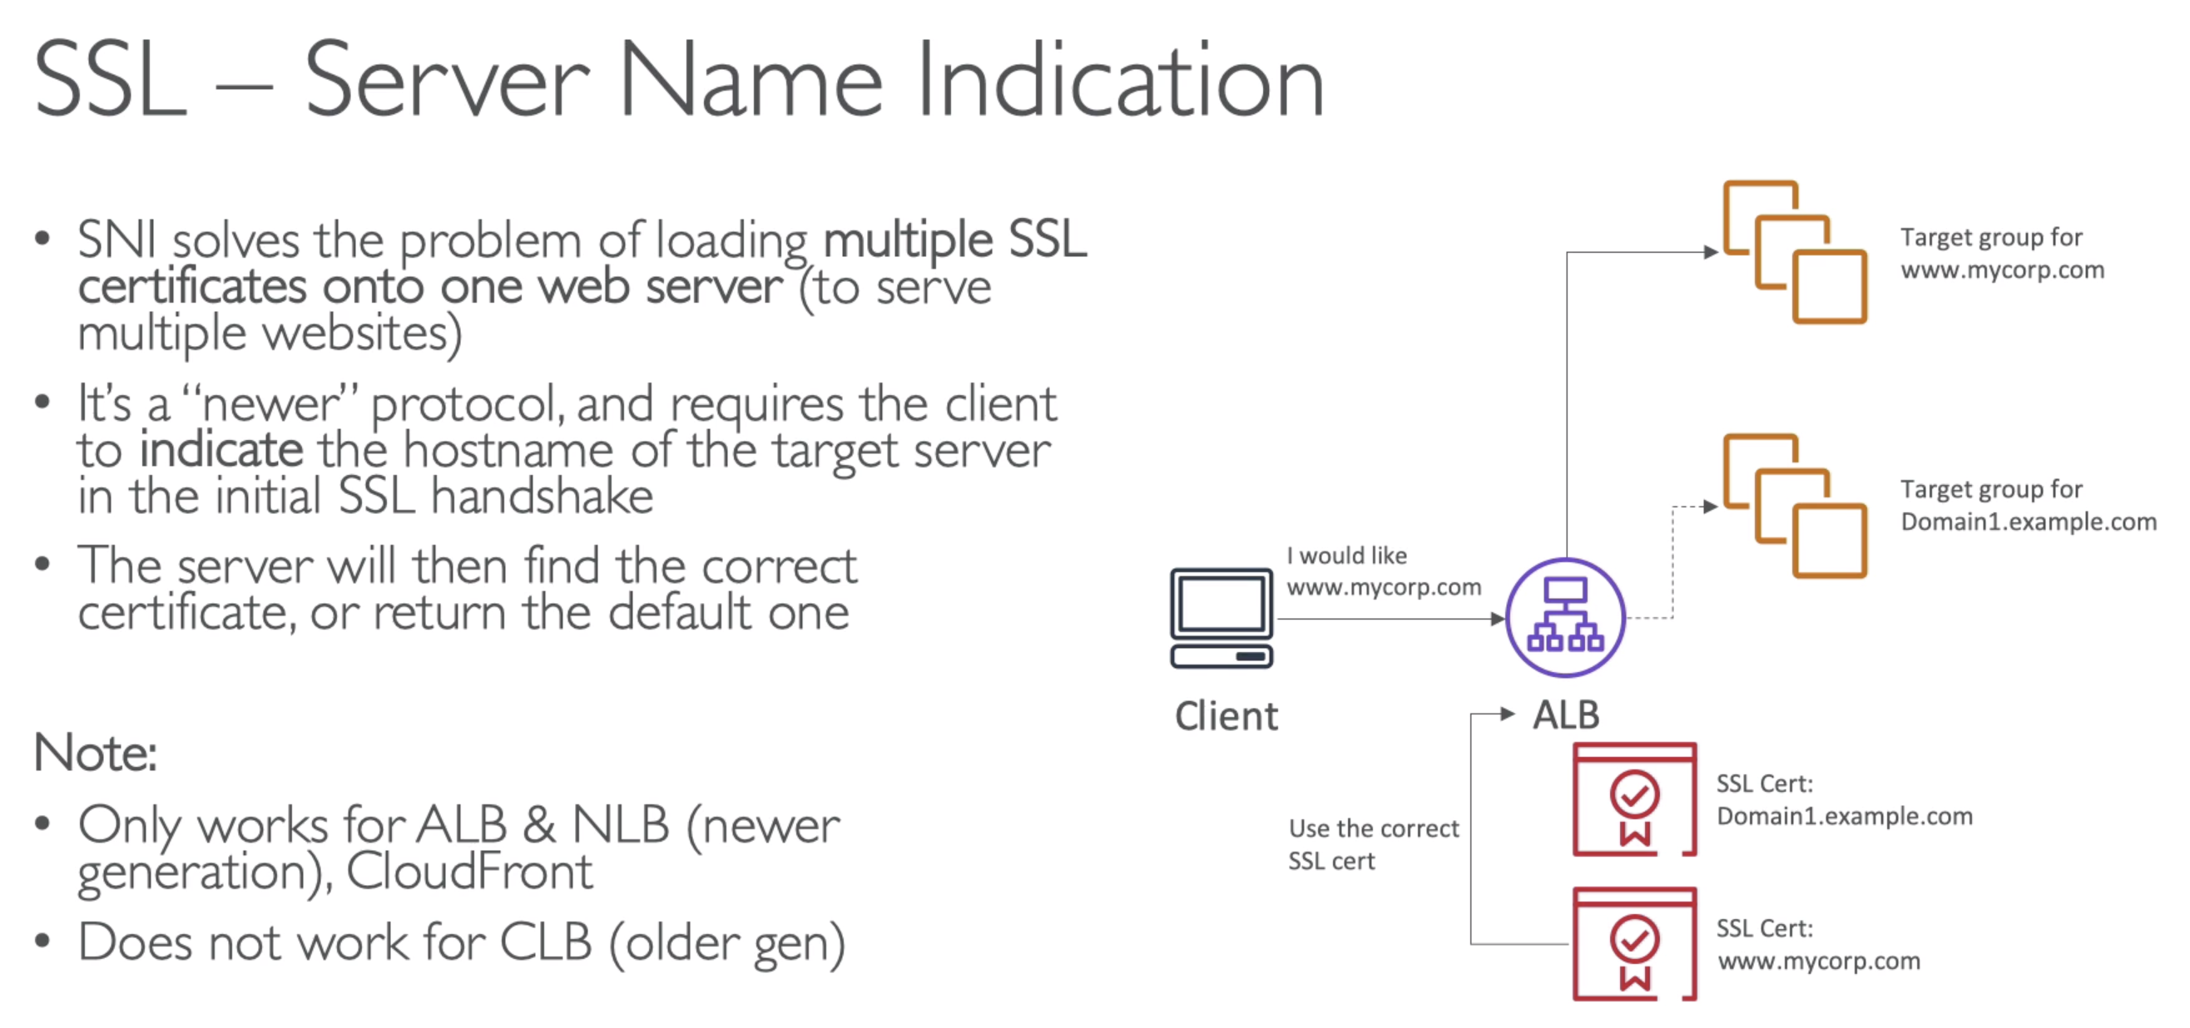

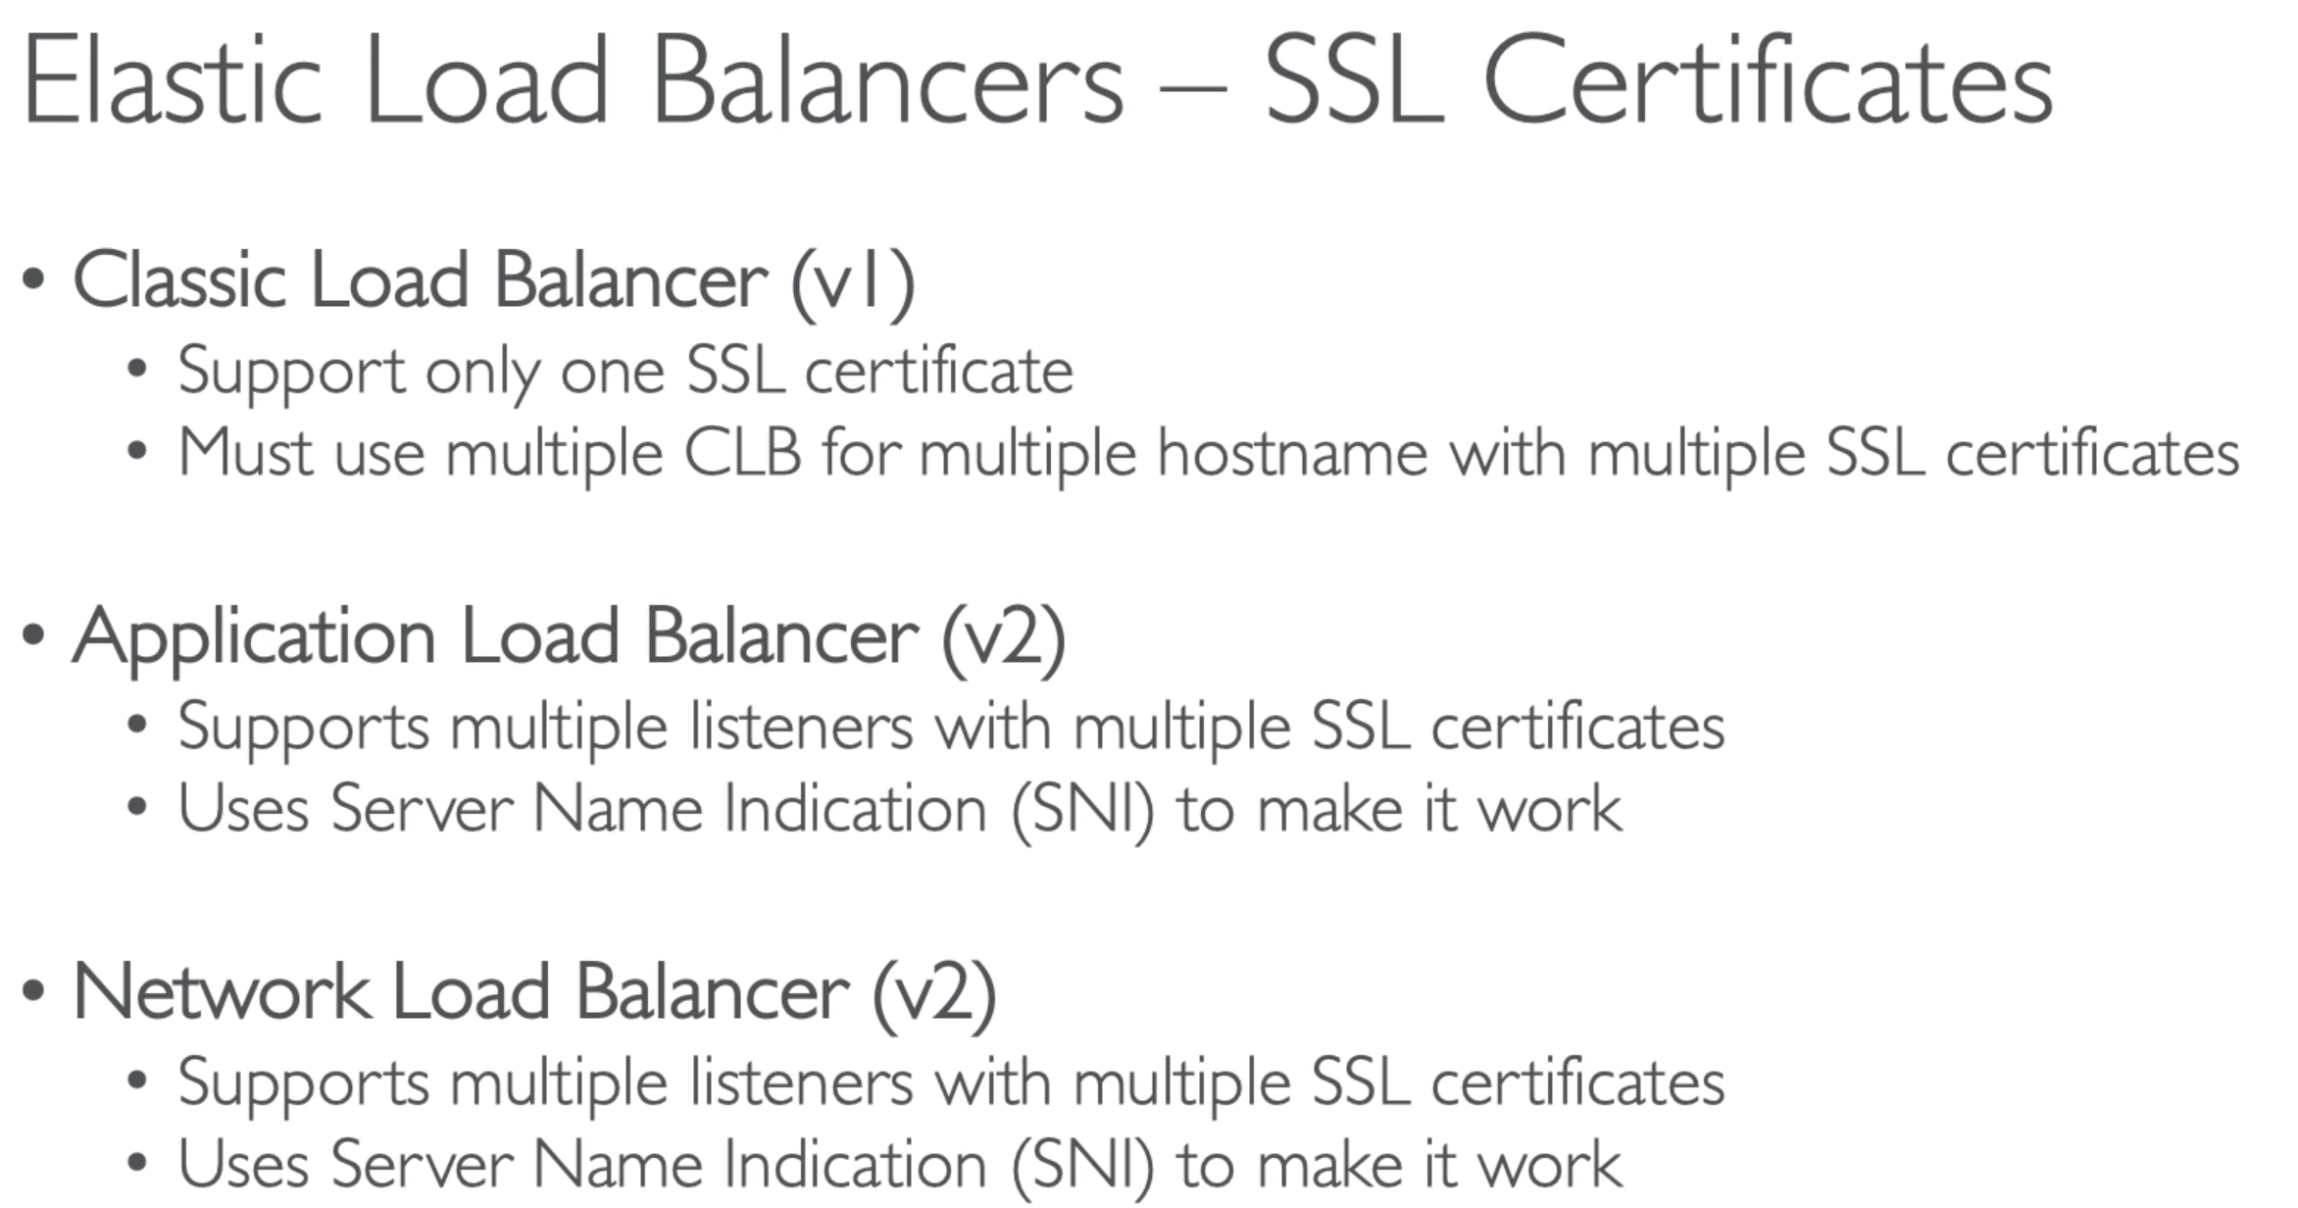

# 51. *ELB – Connection Draining

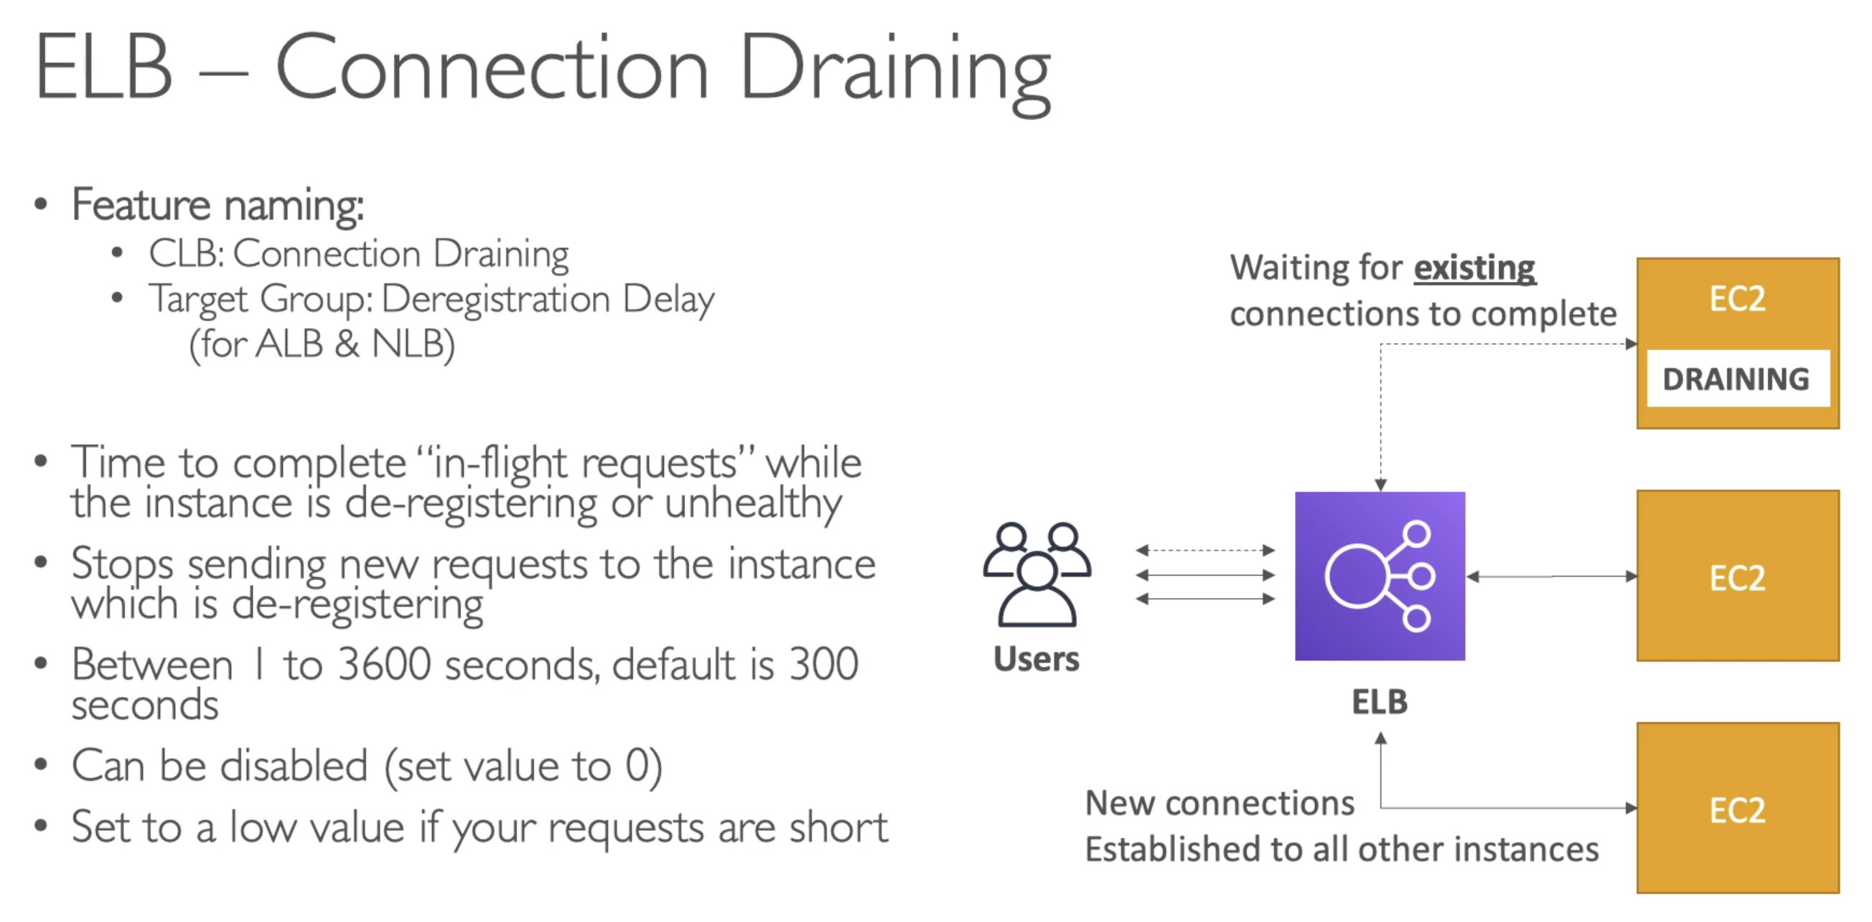

For CLB, it is called Connection Draining. For ALB or NLB – it is called as deregistration delay.

If our EC2 instance is terminated or unhealthy, the existing connection will wait for the connection draining time period to be completed. And by default it is 300 sec.

Any new connection made by other users, will be redirected to new EC2 instances.

# 52. Auto Scaling Group (ASG) Overview

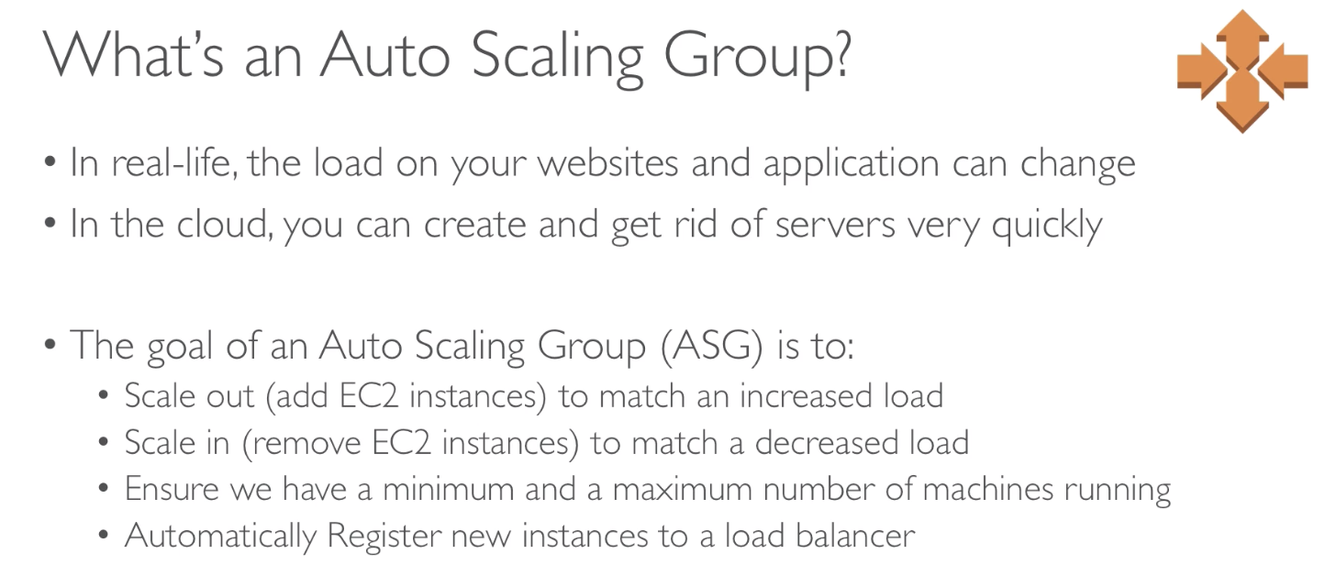

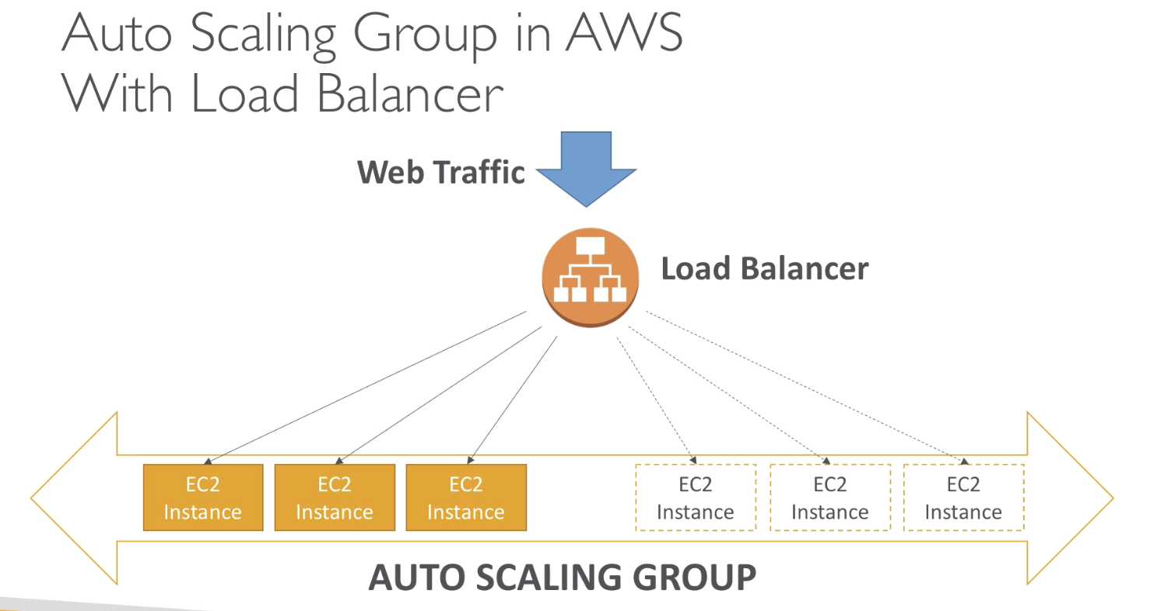

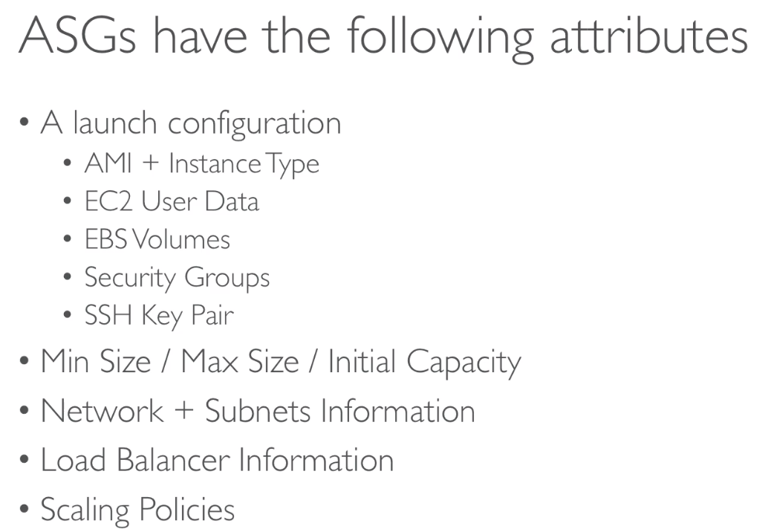

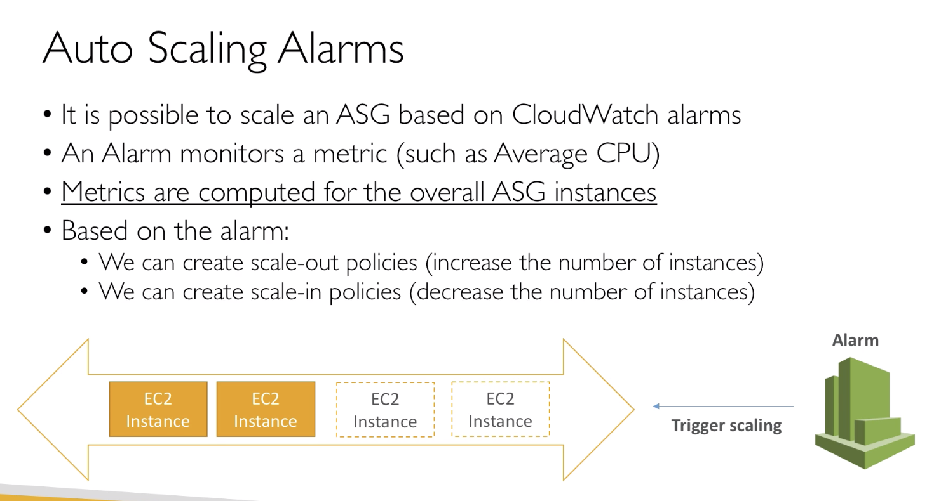

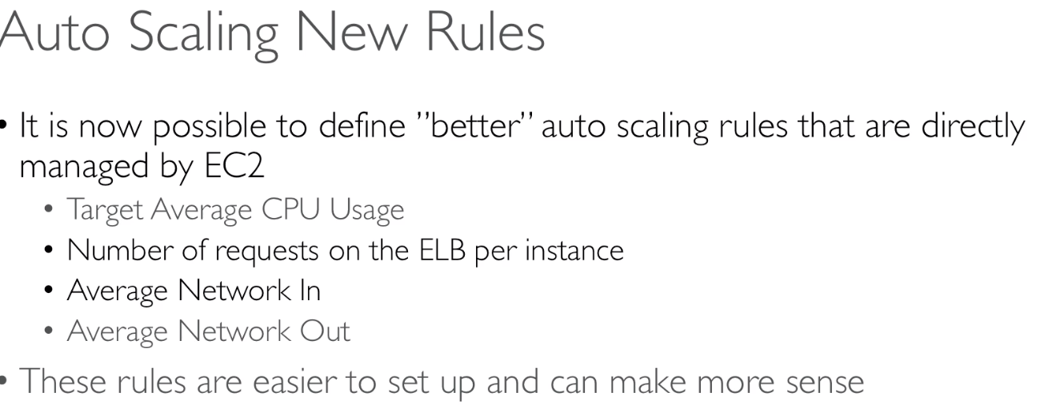

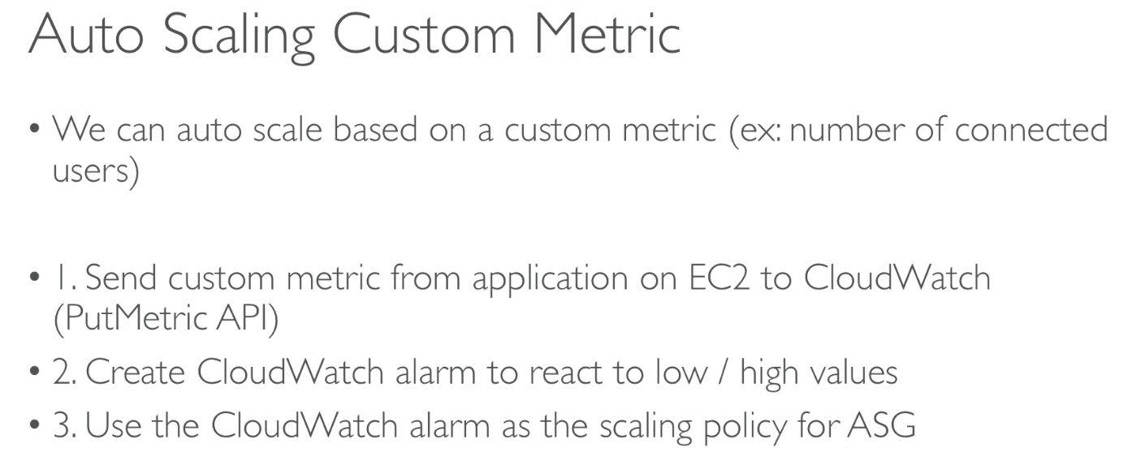

# 54. *ASG – Scaling Policies

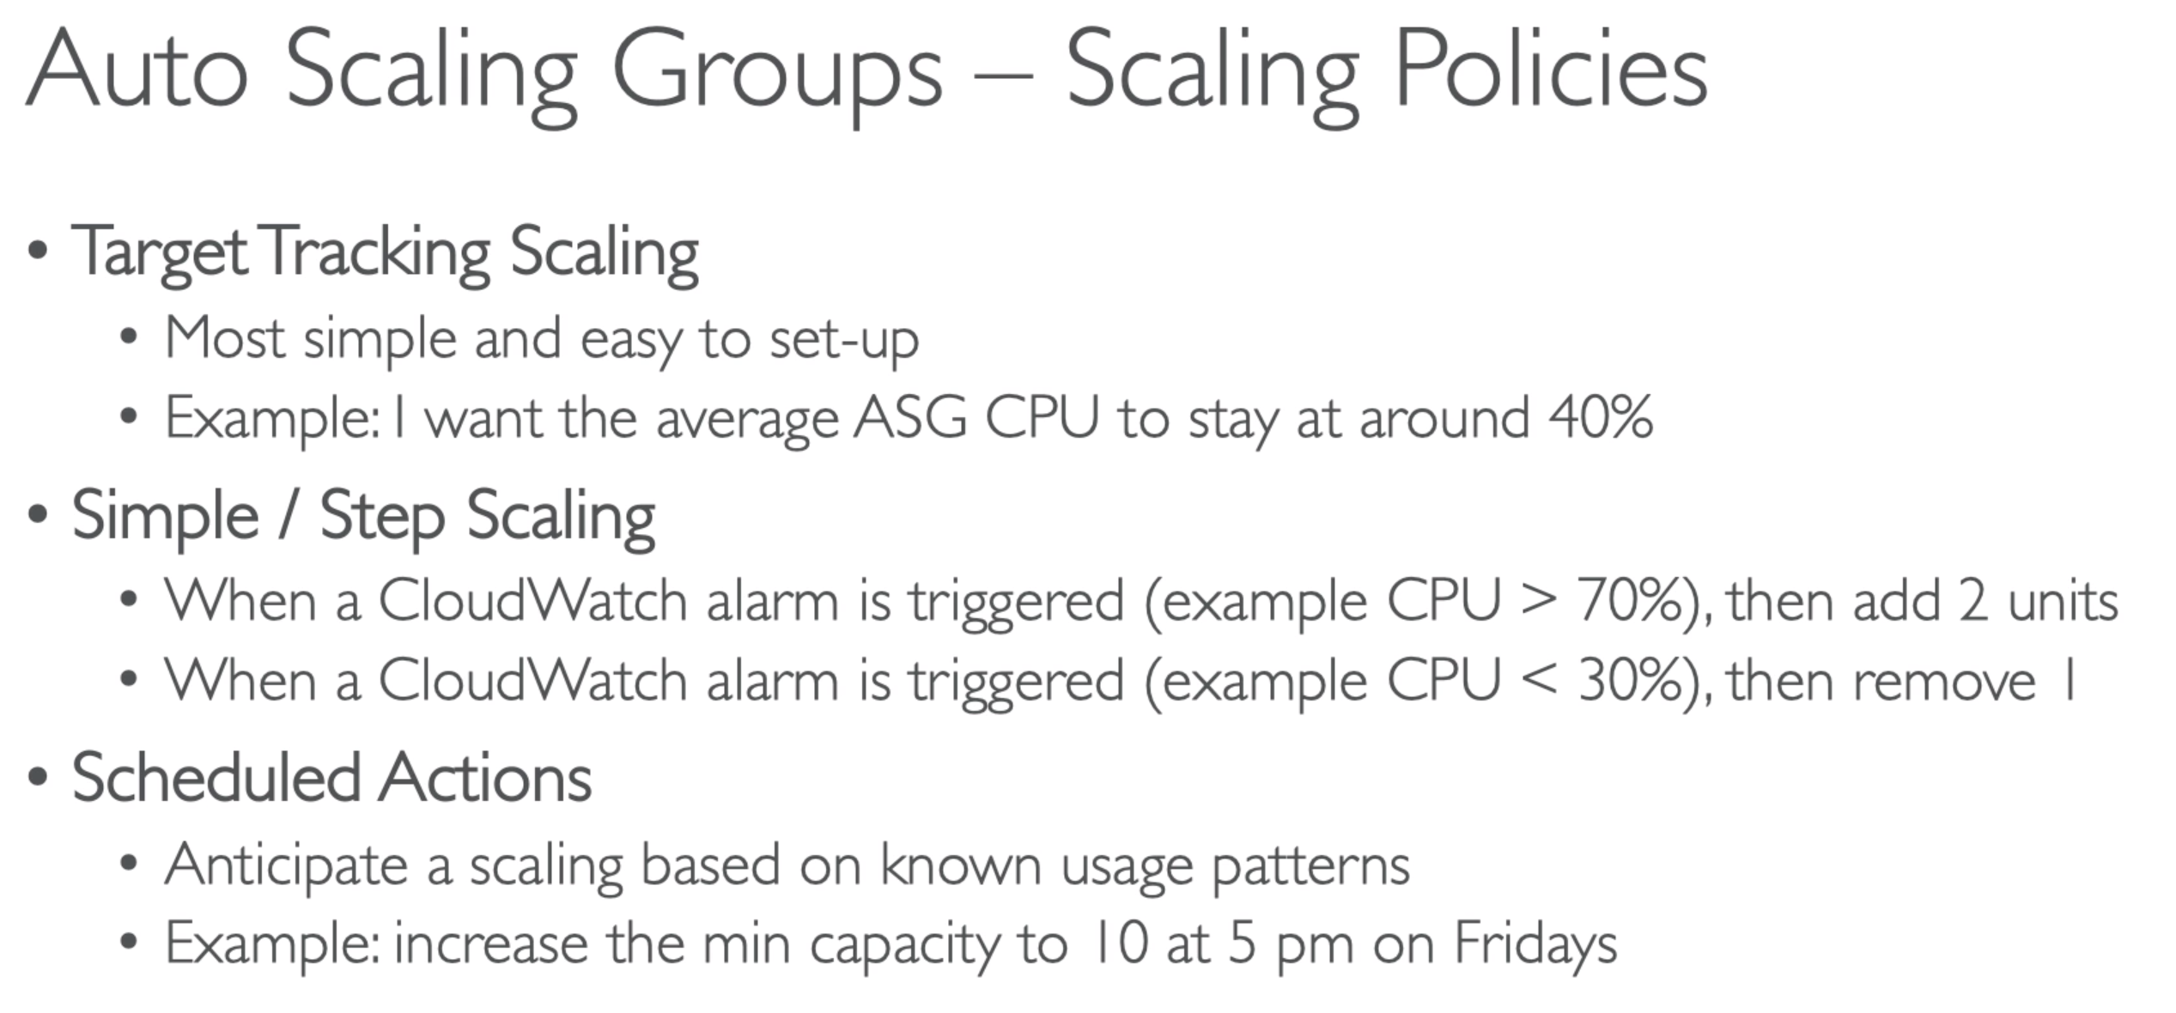

# 55. *ASG – for Solutions Architect

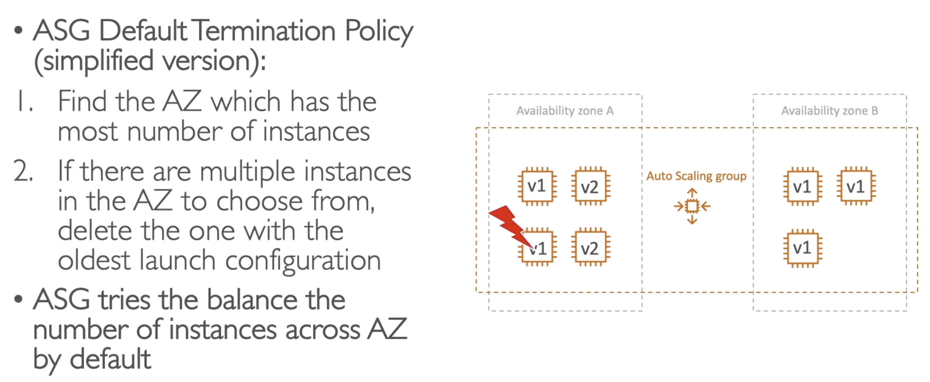

## Imp - Lifecycle Hooks

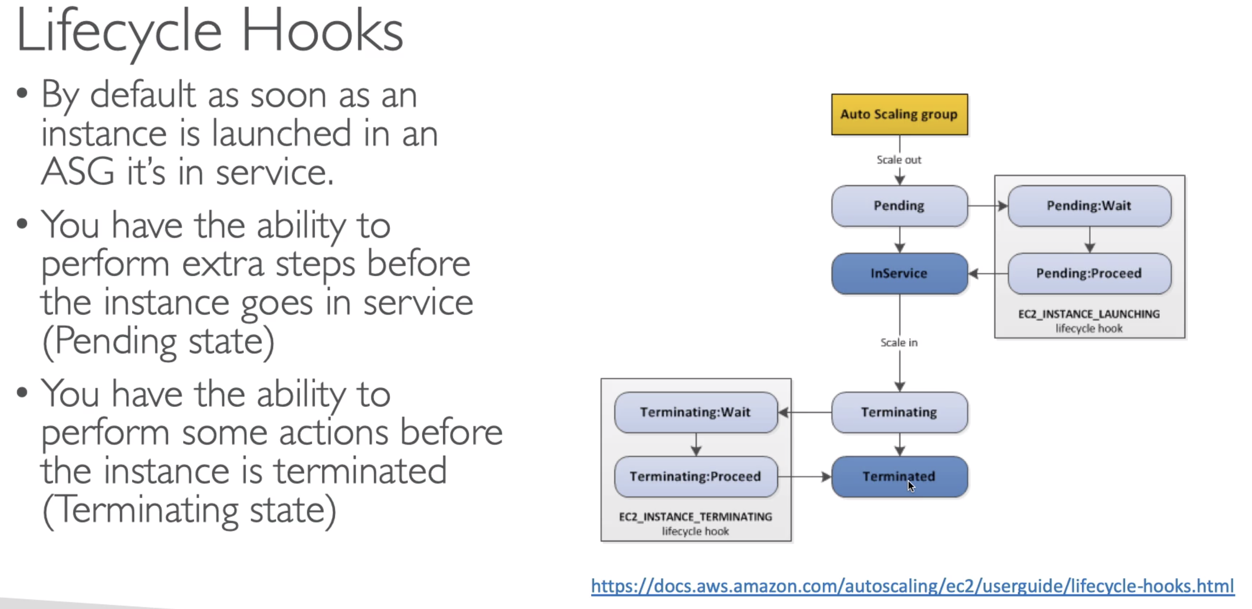

## Imp – Launch Template vs Launch Configuration

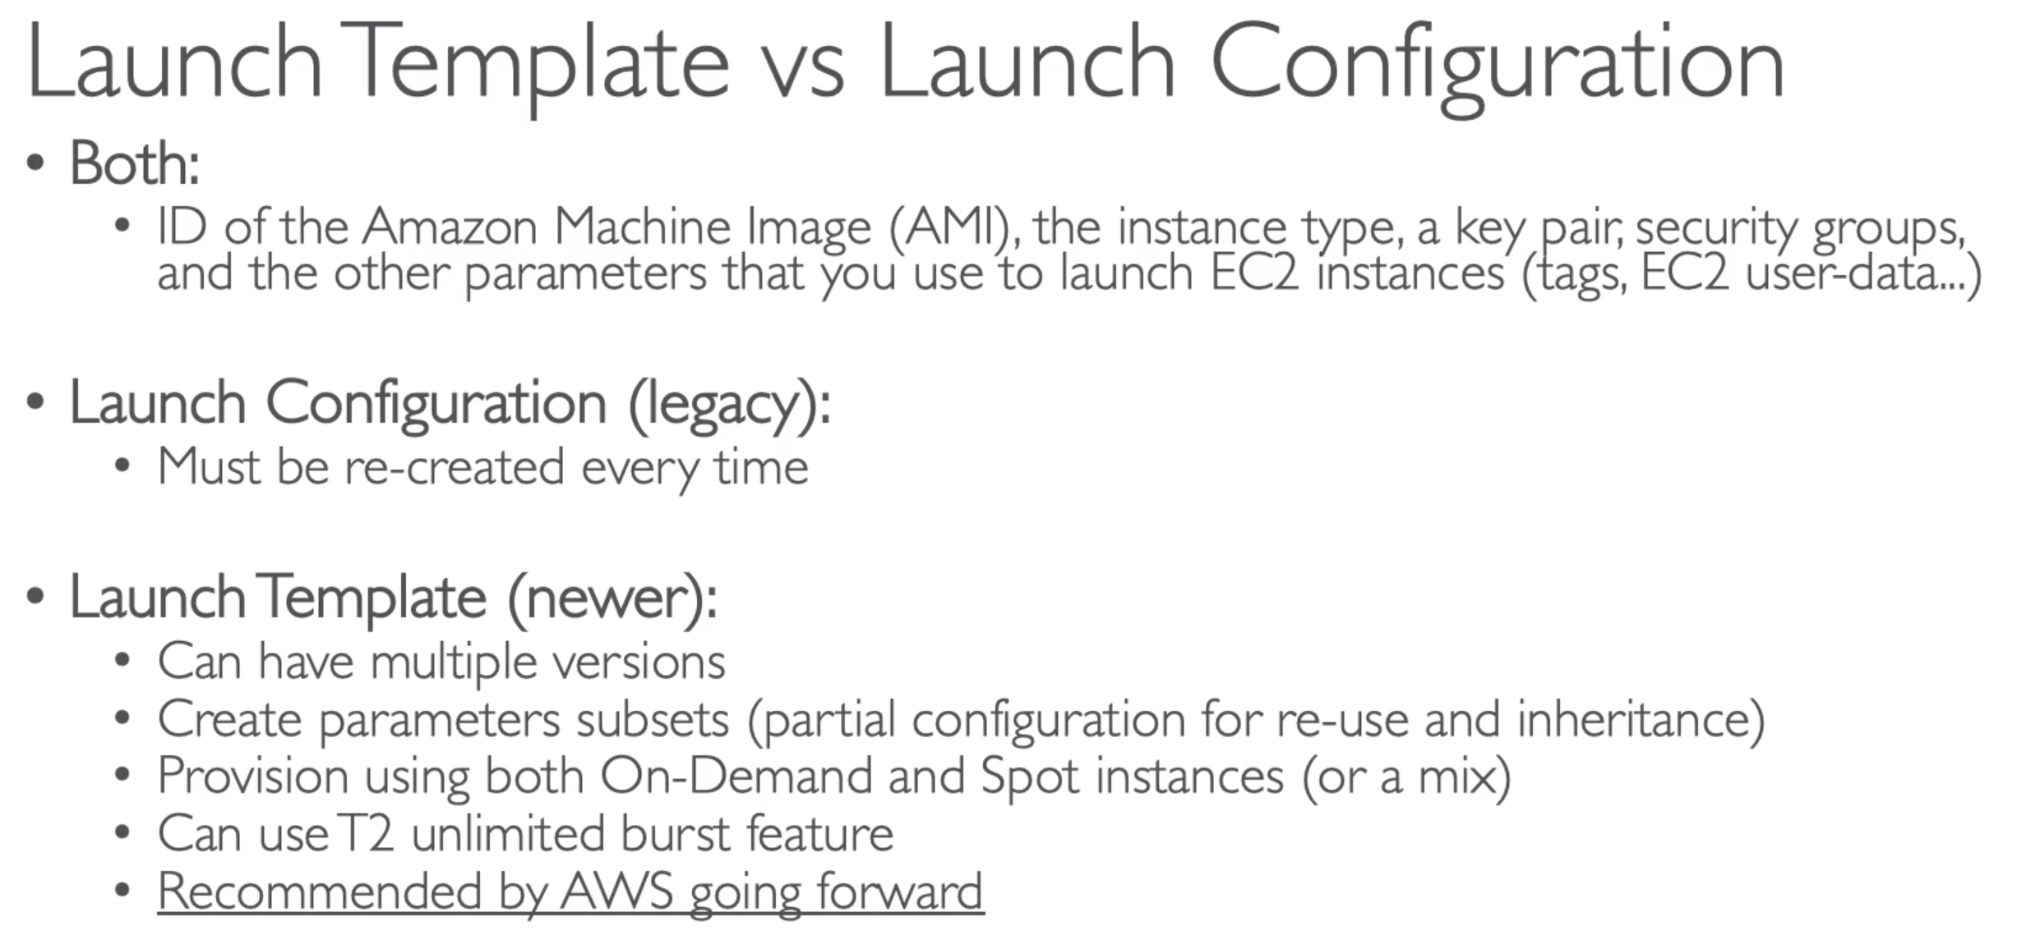

chmod 0400 EC2Tutorial.pem